Name: __________________________________ Date: ___________________ Period: _____
Review Chemistry Unit 12: Solution Chemistry

- A solution consists of a______________________ dissolved in a _________________.

- A solution is a _________________________ mixture. (which means _______ throughout)

Is this type of mixture a pure substance, a compound, both, or neither? (circle one)

- Classify the following materials as: solution (SO) or colloid (C) or Suspensions (SP)
____ a. smoky air ____ g. salt water (NaCl + H₂O)
____ b. sugar water (C₁₂H₂₂O₁₁ + H₂O) ____ h. milk
____ c. vinegar (HC₂H₃O₂ + H₂O) ____ i. soda with bubbles
____ d. mayonnaise ____ j. oil-based paint
____ e. Italian salad dressing ____ k. fog
____ f. cereal ____ l. ethanol in water (C₂H₅OH + H₂O)

- There is a relatively large amount of solute dissolved in a concentrated / dilute solution. (circle one)
There is much more __________________ than __________________ in a dilute solution.

- Molarity is the ratio of _______ of ____________ per ________ of ___________.
A 3.0 molar solution (3.0 M) has _____ mole(s) of solute in every _____ liter(s) of solution.
- To dilute a solution, you can add more __________________ which will change the molarity of the
solution, but will not change the number of _______________ of solute.

- Complete the phrase that describes the types of substances that will generally dissolve in each other:
_______ dissolves _______.

Therefore, polar solvents (like water) can dissolve ___________ solutes (like alcohols, sugars,
ionic compounds, etc.).
But nonpolar solutes (like fats, oils, hydrocarbons, etc.) will dissolve in _______________ solvents.

- A solution is formed by adding methanol, CH₃OH, to water. Identify each of the following intermolecular attractions as breaking or forming in the solution process: (circle answers)
breaking / forming methanol – methanol
breaking / forming water – water
breaking / forming methanol – water

- In general, the stronger the intermolecular attractions between solute and solvent molecules,
the _______________ the solubility.

- In general, the _____________ the intermolecular attractions between solute and solute molecules,
the lower the solubility.

- A tincture of iodine can be used as a disinfectant. This solution is can be made by mixing:

2 g of solid iodine (I₂)
3 g of sodium iodide (NaI)
55 g of liquid ethanol (C₂H₅OH)
40 g of water (H₂O)

The solvent in this mixture is best identified as ____because __________________________________.

A. I₂
B. NaI

C. C₂H₅OH
D. H₂O

- Three factors that typically cause a solid to dissolve faster in a liquid are:
increase / decrease ___________________________
increase / decrease ___________________________
increase / decrease ___________________________

- Gases dissolve faster in liquids at ___________ temperatures and at higher _______________.

- Label each solution as saturated, unsaturated, or supersaturated based on the addition of solute:
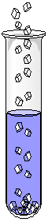

- A solution that contains less solute than can be dissolved at that temperature is ________________.

- If solute crystals are added to a saturated solution, the crystals will…
______________________________________________________________________________.

- If the addition of a seed crystal causes dissolved solute to crystallize, the original solution was
__________________.
For # 18-22, consider the graph of solubility curves below.
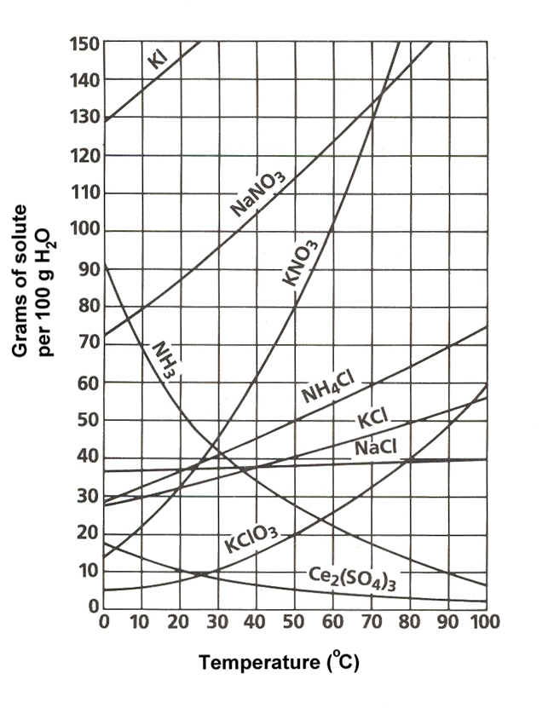
18. Which substance has the lowest solubility at 20ºC?
__________

19. If 40 g of KCl is dissolved in 100 g of water
at 80ºC, then the solution is __________________.

20. If 80 g of KNO₃ is dissolved in 100 g of water
at 40ºC, then the solution is __________________.

21. If 80 g of KNO₃ is dissolved in 100 g of water
at 50ºC, then the solution is __________________.

22. How many grams of NH₄Cl can dissolve in 100 g
of water at 70ºC? _______ g

23. Which of the following usually makes a substance dissolve faster in a solvent?
a. | agitating the solution
b. | increasing the particle size of the solute
c. | lowering the temperature
d. | decreasing the number of particles

24. Which of the following pairs of factors affects the solubility of a particular substance?
a. | temperature and the nature of solute and solvent
b. | temperature and degree of mixing
c. | particle size and degree of mixing
d. | particle size and temperature

25. Which of the following substances is less soluble in hot water than in cold water?
a. | CO | c. | NaNO
b. | NaCl | d. | KBr

26. What does NOT change when a solution is diluted by the addition of solvent?
a. | volume of solvent | c. | number of moles of solute
b. | mass of solvent | d. | molarity of solution

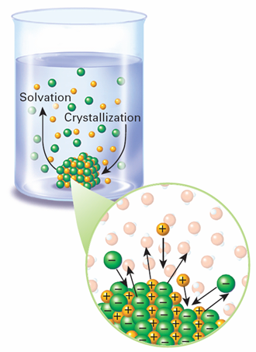

27. Circle the letter of each sentence that is TRUE about
the saturated solution pictured here:

A. The total amount of dissolved solute remains constant.

B. The total mass of undissolved crystals remains constant.

C. When the rate of solvation equals the rate of crystallization,
a state of dynamic equilibrium exists.

D. If more solute were added to the container,
m = mol
kg solvent
the total amount of dissolved solute would increase.

For #28-34, you may use the following formulas:
M₁V₁ = M₂V₂
mol
L
M =

- What is the molarity of a solution that contains 9.50 moles of solute in 3.00 L of solution?

- How many moles of solute are in 3.20 L of a 1.50 M solution of sodium chloride?

- How many moles of solute are in 40.0 g of water in a 0.615 molal solution? (Molality problem)

- How many liters of a 0.510 M solution are contain 0.242 moles of solute?

- What mass of glucose (C₆H₁₂O₆, 180.18 g/mol) is needed to make 5.00 mL of a 0.200 M solution?

- How many mL of a 0.150 M NaBr solution are needed to make 100 mL of 0.0500 M NaBr?

- If 20.0 mL of 12.1 M HCl is used to make a 5.00 L aqueous solution, what is the molarity of the dilute solution? (hint: choose mL or L, not both)

KEY for Calculations #28-34

28. 3.17 M

29. 4.80 mol

30. 0.0246 mol

31. 0.475 L

32. 0.180 g

33. 33.3 mL

34. 0.0484 M

