Unit 6 Part 2 Molecular Compounds and Covalent Bonding Quiz Review
1 – Quick Review – Compounds to Bond Types

Match the following compounds to the three bond types.
Each answer may be used once, more than once, or not at all.
C) Covalent Bond (nonmetal to non) I) Ionic Bond (metal to non) M) Metallic Bond (metals only)
___1. KBr  ___2. Cu  ___3. CO₂  ___4. Pb  ___5. CH₄ | ___6. CaCl₂  ___7. Br₂  ___8. Na₂O  ___9. SiO₂  ___10. brass (Cu + Zn) | ___11. ZnI₂  ___12. Ag  ___13. NaCl  ___14. C_{(graphite)}  ___15. C₃H₈

2 – Lewis Dots of Elements & Ions
Draw Lewis Dot Symbols of the following elements and ions:
Na  Na | Cl  Cl | O  O | I  I | Al  Al

K⁺  K | F⁻  F | S²⁻  S | Br⁻  Br | Ca²⁺  Ca

3 – Electronegativity & Bond Type
Given the following pairs of elements and their electronegativities, decide on the type of bond the two atoms will exhibit.
elements | Higher Electro-negativity | Lower  Electro-negativity | Difference | Bond Type
C-O
Li-N
N-I
H-Cl
N-N
B-F
O-H
Molecular Compounds - How Do Atoms Stick Together?
4 – Lewis Dots of Molecules
Draw the Lewis Symbols of the following molecules. Only single bonds are used.

Br₂ | CBr₄ | H₂O₂
H₂S | PH₃ | SiH₄

5 – Polar or Non-polar Molecule?
State whether each molecule below is polar or non-polar. Explain to each other why you made your choice.
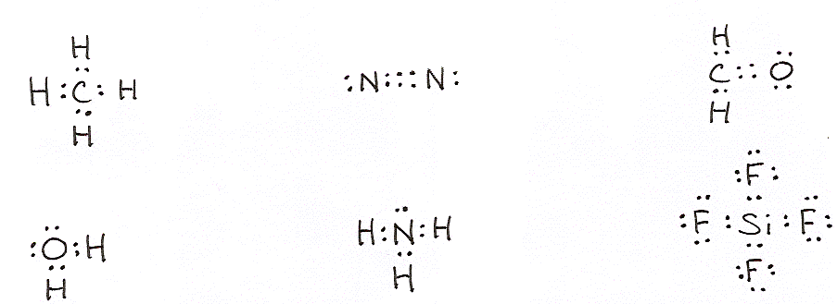

6 – Lewis Dots of Molecules
Draw the Lewis Symbols of these molecules that include double and triple bonds.

P₂ | Se₂ | C₂Cl₂

Unit 7 – How Do Atoms Stick Together?
Station 5 – Intermolecular Forces of Attraction
For each substance, state the type of IMF that holds the solid together. Place an below the box.

Substance | London  Forces | Dipole-  Dipole | Hydrogen  Bonding | Metallic  Bonds | Ionic  Bonds | Covalent  Bonds
C_{(graphite)}
Au
KBr
H₂O
CH₃OH
SiO₂
CO₂
SF₂
brass
(Zn + Cu)
He

Unit 7 – How Do Atoms Stick Together?
Station 7 – Quick Quiz – Properties of Types of Bonds
Match the following statements to the three bond types.
Each answer may be used once, more than once, or not at all.

C) Covalent Bond I) Ionic Bond M) Metallic Bond
___1. the strongest bond  ___2. conducts electricity as a solid  ___3. alternating positive and negative particles  ___4. sharing electrons between two atoms  ___5. positive ions in a “sea of electrons” | ___6. malleable and ductile  ___7. conducts electricity when dissolved in water  ___8. involves a transfer of electrons  ___9. involved in molecules and in network solids  ___10. does not usually conduct electricity  Exception?: _______________

