Study Guide: Chemistry Semester 1
If you need help answering these study guide questions, check online for the notes:
http://msrobbinspnhs.weebly.com/ or http://mrsgonsalves.weebly.com/

Atomic & Molecular Structure
Standard 1
Atomic number
Atomic structure
- Draw an atomic model of
Carbon-13.
In the drawing include the following:
- Location of nucleus & electron cloud.
- Location of 3 subatomic particles.
- Amount of each subatomic particles.
- A note where most of the atom’s mass is found.

- What is atomic number?

- What is atomic number for the following elements?
Cr | Iron
Carbon | Ca

- How does atomic number change moving left to right across the periodic table?

Atomic Weight (Atomic Mass)
- What is the atomic mass for the following elements?
Organization of the Periodic Table
- Identify on the periodic table below the location of
The 3 different types of elements.
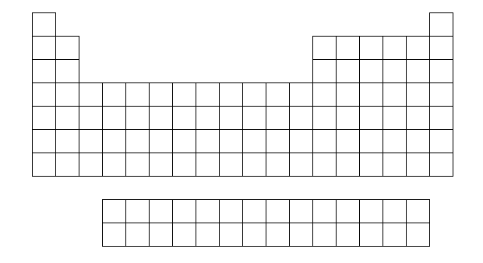
- Where are groups on the periodic table?

- Where are periods on the periodic table?
V | Oxygen
Beryllium | Mn
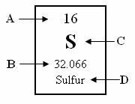
- It was found that the periodic table was organized by increasing atomic number rather than mass. Give an example of a pair of elements where one element has a larger atomic number but a smaller atomic mass.

- Identify the letters in the following periodic square:

Periodicity (periodic trends)
- Atomic Radius
  - Which element has the largest atomic radius?

  - Which element has the smallest atomic radius?

- Ionization energy
  - What is Ionization Energy?

  - Which element has the largest ionization energy?

  - Which element has the lowest ionization energy?

  - Why does ionization energy decrease moving down a group?

- Electronegativity
  - What is Electronegativity?

  - Which element has the largest electronegativity?

  - Which element has the lowest electronegativity?

  - Why do Noble Gases tend to have no electronegativity?
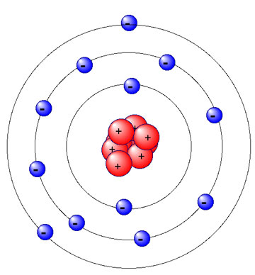

Valence electrons
- Why are alkali metals so reactive?

- Why are halogens so reactive?

- Identify the amount of valence electrons in each of the following:
- How many of magnesium atom’s 12 electrons are valence electrons? Circle those electrons.
Na | Phosphorus
Argon | He

Review Chemistry I: Ionic Bonding and Nomenclature
- Positive ions are called ______________. Negative ions are called ______________.

- Why do chemical bonds form between atoms? (or…Why don’t atoms just stay single?)
________________________________________________________________________________________________________________________________________________________________
- In an ionic bond, electrons are shared / transferred / connected between atoms. (circle one)

- An ionic bond is a chemical bond caused by electrostatic ______________________ between
______________ and _____________ that is formed by ______________________ electrons between atoms.
- Ionic bonds form between ____________ and ____________. (metals, nonmetals, metalloids)
- For the pairs of elements listed below, circle pairs that would likely form ionic bonds.

C and H Na and F Hg and Ag Mg and S N and C K and O
- What is a polyatomic ion? ______________________________________________________________________________
- Circle the ionic compounds listed below.

CaSO₄ CH₄ CO₂ BaCl₂ NH₃ KNO₃ LiOH

- How did you know which compounds in Question 8 above were ionic?
________________________________________________________________________________________________________________________________________________________________
- What are binary ionic compounds? ________________________________________________________________________________
- Binary ionic compounds typically end with the suffix –_____.

- A “formula unit” is the simplest or lowest ____________ of ___________ in an ionic compound.

- How do each of the following atoms achieve a stable octet?
(circle gain or lose and write in a number of electrons)
O will gain / lose ___ electrons
Li will gain / lose ___ electrons
N will gain / lose ___ electrons
- List the oxidation number (charge) for the following groups of elements.
Group 1 ___ Group 15 ___
Group 2 ___ Group 16 ___
Group 3 ___ Group 17 ___

- List 3 physical properties of ionic compounds:

1. State: solid / liquid / gas (circle)
2. Melting Point: high / low (circle)
3. Conductor of electricity when _________________ or _______________
- Determine the total number of atoms in each formula listed below.

Li₃PO₄ ____ Ba(NO₃)₂ ____
- Determine the total number of ions in each formula listed below.

Li₃PO₄ ____ Ba(NO₃)₂ ____
- Which of the following compounds contains the Sn⁴⁺ ion?

a. Sn₂Br
b. SnCI
c. SnI₂
d. SnO₂

- Name the following compounds.

MgI₂ _____________________________ Fe₂O₃ ___________________________

Al(NO₃)₃ _____________________________ NH₄Br ___________________________

CuCO₃ _____________________________ KHCO₃ ___________________________

Ba(C₂H₃O₂)₂ _____________________________ SnCl₄ ___________________________

- Write a formula for the following chemical compounds.

copper(I) oxide ______________ ammonium nitrate ______________

potassium phosphate ______________ I ron(III) sulfide ______________

calcium hydroxide ______________ lead(II) iodide ______________

aluminum sulfate ______________ nickel(II) bromide ______________

- Draw a Lewis Dot diagram for each the following ionic compounds.

NaF CaCl₂ K₂S

- What is the oxidation number of the unknown element X in the compound MgX₂?

a. 1–
b. 2–
c. 1+
d. 2+
Review Chemistry I: Covalent Bonding and Nomenclature

1. Why do atoms share electrons in covalent bonds with other atoms rather than remaining as single atoms?
________________________________________________________________
________________________________________________________________

2. A molecule is a neutral group of atoms held together by ______ .

A. ionic bonds
B. unshared electrons
C. partial charges
D. covalent bonds

3. Compounds formed by covalent bonds usually contain _______________.

A. halogens and oxygen
B. two or more nonmetals
C. a metal and a nonmetal
D. positive and negative ions

4. Which of the following is a molecular compound?

A. Na₂O
B. AlCl₃
C. SCl₆
D. CuO

C C
5. How do atoms form covalent double bonds?
A. One atom loses two electrons to the other atom in the bond.
B. Two atoms share two pairs of electrons.
C. Two atoms share two single electrons.
D. Two atoms share one electron.
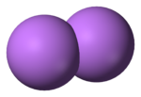
?
?
6. Which of these elements does NOT exist as a diatomic molecule?

A. P
B. Cl
C. O
D. N

7. A bond formed between a carbon atom and hydrogen atom is likely to be ____.

A. single, covalent
B. double, covalent
C. ionic
D. triple, covalent

8. Which of the following bonds is the most polar (i.e. has the greatest difference in electronegativity)?

A. C—C
B. H—N
C. O—H
D. H—Cl

9. Which of the following covalent bonds is the least polar?

A. H—Cl
B. H—C
C. Cl—Cl
D. H—N

10. Which is TRUE of a nonpolar covalent bond?
A. electrons are shared unequally between atoms
B. a cation is bonded to an anion
C. electrons are transferred between atoms
D. electrons are shared equally between atoms

11. Draw the Lewis dot structure for CO₂ in the box

12. Describe properties that are common in typical molecular compounds.

conductor: good or poor
melting point: high or low
boiling point: high or low
net charge: neutral or charged

#13-18 Write the NAME or FORMULA for the following molecular compounds:

13. CS₂ ______________________________

14. CCI₄ ______________________________

15. S₂O₆ ______________________________

16. triboron monoxide _______

17. tetraphosphorus pentoxide _______

18. arsenic trihydride _______

19. In drawing a Lewis structure, what is special about hydrogen (H₂) ?
A. It achieves an octet of 8 electrons.
B. It can form up to four bonds with 8 shared electrons.
C. It can only form one double bond.
D. It can only form one single bond with no unshared electrons around it.

For #20-25:

-Draw the Lewis dot structures for the following compounds.
-List how many unshared pairs of electrons are in the molecule.
20. HBr unshared pairs: ___

21. NI₃ unshared pairs: ___

22. N₂ unshared pairs: ___

23. Cl₂ unshared pairs: ___

24. SO₂ unshared pairs: ___

25. CH₂F₂ unshared pairs: ___

KEY Review Chemistry I: Ionic Bonding and Nomenclature
- Positive ions are called cations. Negative ions are called anions.

- The formation of chemical bonds results in the formation of a more stable electron configuration (in some cases, an octet) for atoms.

- transferred

- An ionic bond is a chemical bond caused by electrostatic _attraction_ between _cations___ and __anions__ that is formed by __transferring__ electrons between atoms.

- Ionic bonds always from between __metals__ and __nonmetals_. (metals, nonmetals, metalloids)

- Na & F , Mg & S , K & O

- A group of atoms with a charge

- CaSO₄, BaCl₂, KNO₃, LiOH

- metal bonded to a nonmetal or metal with a polyatomic ion

- Ionic compound consisting of only two different elements

- –ide

- ratio (or combination) , ions

- O gain 2 electrons Li lose 1 electron N gain 3 electrons

- Group 1: 1+ Group 15: 3-
Group 2: 2+ Group 16: 2-
Group 3: 3+ Group 17: 1–

- Ionic compounds: solid, high, melted, dissolved

- Li₃PO₄ : 8 atoms Ba(NO₃)₂ : 9 atoms

- Li₃PO₄ : 4 ions Ba(NO₃)₂ : 3 ions

- D. SnO₂

- MgI₂ magnesium iodide Fe₂O₃ iron(III) oxide
Al(NO₃)₃ aluminum nitrate NH₄Br ammonium bromide
CuCO₃ copper(II) carbonate KHCO₃ potassium bicarbonate
Ba(C₂H₃O₂)₂ barium acetate SnCl₄ tin(IV) chloride

- copper(I) oxide Cu₂O ammonium nitrate NH₄NO₃
potassium phosphate K₃PO₄ iron(III) sulfide Fe₂S₃
calcium hydroxide Ca(OH)₂ lead(II) iodide PbI₂
aluminum sulfate Al₂(SO₄)₃ nickel(II) bromide NiBr₂
[ ]
[ ]⁻
[K]⁺
[K]⁺
- 1–

http://hs.sharon.k12.ma.us/pages/Sharon_High_School/FACULTY_AND_STAFF/Science/6275490624862862498/Chemistry_MCAS_Exams_2004-2012

KEY Review Chemistry I Unit 6: Covalent Bonding and Nomenclature

1. Why do atoms share electrons in covalent bonds with other atoms rather than remaining as single atoms?
Atoms form covalent bonds to obtain more stable electron arrangements.
2. A molecule is a neutral group of atoms held together by ______ .
A. ionic bonds
B. unshared electrons
C. partial charges
D. covalent bonds
3. Compounds formed by covalent bonds usually contain _______________.
A. halogens and oxygen
B. two or more nonmetals
C. a metal and a nonmetal
D. positive and negative ions
4. Which of the following is a molecular compound?
A. Na₂O
B. AlCl₃
C. SCl₆
D. CuO
C C
5. How do atoms form covalent double bonds?
A. One atom loses two electrons to the other atom in the bond.
B. Two atoms share two pairs of electrons.
C. Two atoms share two single electrons.
D. Two atoms share one electron.
6. Which of these elements does NOT exist as a diatomic molecule?
?
?
A. P
B. Cl
C. O
D. N
7. A bond formed between a carbon atom and hydrogen atom is likely to be ____.
A. polar covalent
B. dipolar
C. ionic
D. nonpolar covalent
8. Which of the following bonds is the most polar (i.e. has the greatest difference in electronegativity)?

A. C—C
B. H—N
C. O—H
D. H—Cl

9. Which of the following covalent bonds is the least polar?
A. H—Cl
B. H—C
C. Cl—Cl
D. H—N
10. Which is TRUE of a nonpolar covalent bond?
A. electrons are shared unequally between atoms
B. a cation is bonded to an anion
C. electrons are transferred between atoms
D. electrons are shared equally between atoms

11. Draw the Lewis dot structure for CO₂ in the box:
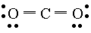

Does CO₂ contain polar bonds? _Yes_ If so, how many? _2__

Is CO₂ a polar molecule? No If not, explain why not. The polar bonds are
arranged symmetrically and cancel out.

12. The following molecules contain polar bonds. Which is the only nonpolar molecule?
(hint: drawing the Lewis structures can help)
A. HCl
B. NH₃
C. H₂O
D. CBr₄
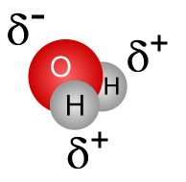

water molecule
water molecule

13. Water molecules are polar because they have polar bonds (due to different electronegativities)
that are arranged asymmetrically (do not cancel out).
14. Describe properties that are common in typical molecular compounds.
conductor: good or poor
melting point: high or low
boiling point: high or low
net charge: neutral or charged
#15-20 Write the NAME or FORMULA for the following molecular compounds:

15. CS₂ carbon disulfide

16. CCI₄ carbon tetrachloride

17. S₂O₆ disulfur hexoxide

18. triboron monoxide B₃O

19. tetraphosphorus pentoxide P₄O₅

20. arsenic trihydride AsH₃

21. In drawing a Lewis structure, what is special about hydrogen (H) ?
A. It achieves an octet of 8 electrons.
B. It can form up to four bonds with 8 shared electrons.
C. It can only form one double bond.
D. It can only form one single bond with no unshared electrons around it.

For #22-27,
-Draw the Lewis dot structures for the following compounds.
-List how many unshared pairs of electrons are in the molecule.
-Identify the molecule as polar or nonpolar by circling the correct label.

22. HBr unshared pairs: _3_

23. NI₃ unshared pairs: _10_

24. N₂ unshared pairs: _2_

25. Cl₂ unshared pairs: _6_

26. SO₂ unshared pairs: _6_

27. CH₂F₂ unshared pairs: _6_

