Name:___________________________________ Date:_______________ Period:___

**Unit 3 TEST Review: The Periodic Table as a Model**

1. Elements in the same family or group have same number of _________________electrons.

2. Classify the elements below as: **metal , nonmetal , metalloid**

a. sulfur ___________ d. magnesium ____________

b. iron ___________ e. silicon ____________

c. hydrogen ___________ f. chromium ____________

3. Write the symbol for the mystery element based on the clue.

_____ a. non-reactive, stable element having the smallest radius in its group

_____ b. halogen having the highest ionization energy

 _____ c. period 4 element, having 6 valence electrons

_____ d. transition metal having the smallest atomic mass in Group 8

_____ e. period 3 metal with one valence electron

_____ f. Group 14 element with the lowest atomic number

_____ g. alkaline earth metal having the lowest ionization energy

_____ h. has 2 more protons than carbon

_____ i. period 4 element with 5 valence electrons

_____ j. very reactive group 1 element, found in period 6

_____ k. the most electronegative element on the periodic table

4. A chemist needs calcium to perform an experiment in the lab and discovers that she does not have

any calcium. List the two elements that she could use for this experiment to best replace calcium.

_______________________ _____________________

Explain your choices: ______________________________________________________________

5. For each family (or group) of elements, describe the area of the periodic table in which it is located.

a. alkali metals ________________________________

b. halogens ________________________________

c. transition metals ________________________________

d. alkaline earth metals ________________________________

e. noble gases ________________________________

f. inner transition metals ________________________________

g. representative elements _________________________________

6. The periodic table was developed by Mendeleev in the 1800s. He arranged the elements that were

known at the time by increasing atomic ________________ and placed them into groups based on

similar _________________.

7. What was Mendeleev able to do using the periodic table that he designed?

8. What does each period number on the periodic table represent about the atoms in that period?

9. What is the amount of energy required to remove an electron from an atom?

_______________________________________

10. What is an atom's ability to attract electrons when involved in a chemical bond?

_______________________________________

11. How many valence electrons do each of the following groups or families of elements have?

a. halogens ____

b. noble gases ____

c. Group 2 ____

d. Group 13 ____

e. alkali metals ____

f. group 16 (6A) ____

g. Group 14 (4A) ____

h Group 15 (5A) ____



12. For the elements listed above, which element has the largest atomic radius? ____

Which element has the smallest atomic radius? ____

These atoms change size from left to right. Why do their sizes follow this trend from left to right?

_______________________________________________________________________________



13. Place the highlighted elements in the periodic table in order from *largest to smallest* by

atomic radius.

____ > ____ > ____ > ____

14. Circle the largest of the 2 particles.

a. Ca, or Ca+2

b. Ba, or Ba+2

c. F, or F –1,

d. Br, or Br –1



15. Which element above has the *lowest* ionization energy? ________

Which element has the *highest* ionization energy? _______

**Figure B**

**Figure A**



***Most Reactive: Either loses or gains electrons the easiest***

16. Organize the elements in **Figure A** from *least to most* reactive.

_____ < _____ < _____ < _____ < _____

Organize the elements in **Figure B** from *least to most* reactive.

_____ < _____ < _____ < _____ < _____

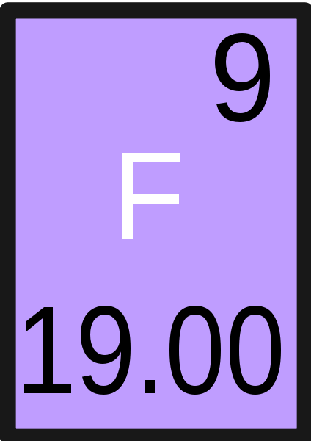17. Fill in the missing information for the element fluorine.

a. F has the ___________ atomic radius in its group.

b. F has the ___________ ionization energy in its group.

c. F has the ___________ electronegativity in its group.

d. F is the __________ reactive element in its group.

**For questions 18 – 20**, use this graph showing the first ionization energies of elements 1-19.

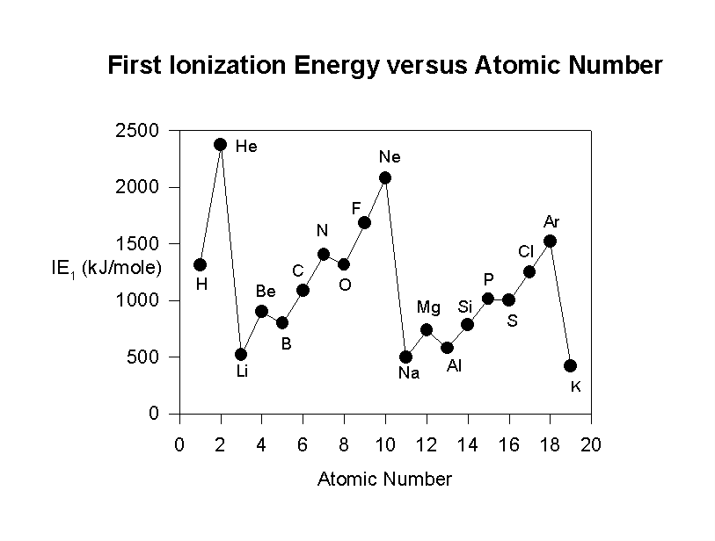

Graph showing the

1st ionization energies

of elements 1-19

18. What does the graph show about the elements He, Ne and Ar?

They have the _____________ ionization energies because their outermost energy level has

__________ electron(s) and is held closer to the atom’s _______________ by extra ___________.

What does this indicate about their stability? relatively stable or fairly reactive

19. What does the graph show about the elements Li, Na, and K?

They have the _____________ ionization energies because their outermost energy level has

__________ electron(s) and is located _______________________ the atom’s nucleus.

What does this indicate about their stability? relatively stable or fairly reactive

20. The direction of the line graph from Li to Ne and from Na to Ar generally goes up as atomic number

increases. But it drops suddenly from Ne to Na and from Ar to K.

Why does this sudden drop occur from Ne to Na?

A. atomic radius decreases

B. atomic number increases

C. valence electron now in energy level further from nucleus

D. valence electron now attracted more to the nucleus