Name:____________________________ Date:___________ Period:____
Extra Review Unit 3: Atomic Theory and Structure
Define each of the following terms:
1. atom:
2. proton:
3. electron:
4. neutron:
5. nucleus:
6. atomic mass:
7. isotope:
8. mass number:
9. atomic number:

10. Avogadro’s number:

Circle or write in the correct answer:

12. Which of the following was originally a part of Dalton's atomic theory, but had to be revised later based on new experimental evidence? (circle all that apply)
A. Atoms are tiny indivisible particles.
B. Atoms of the same element are identical.
C. Atoms of different elements can sometimes be identical.
D. Compounds are made by combining atoms.

13. Consider J.J. Thomson’s cathode ray tube experiment. Briefly describe what occurred that gave evidence of electrons in all atoms.
___________________________________________________________________
___________________________________________________________________

14. Which of the following is FALSE about subatomic particles?
A. Electrons are negatively charged and are the lightest subatomic particle.
B. Protons are positively charged and have nearly the same mass as neutrons.
C. Neutrons have no charge and have no mass.
D. The mass of a neutron nearly equals the mass of a proton.

15. All atoms are neutral because the number of __________________ always equals
the number of __________________ in every atom.
Fill in the chart with a charge and mass: Charge (+ , – , or 0 ) Mass (1 or 0)
Proton ____ ____
Neutron ____ ____
Electron ____ ____

Rutherford Gold Foil Experiment
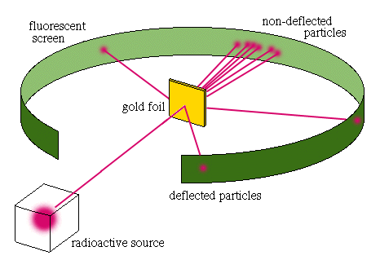
gold atom
gold atom
expected results
actual results

16. What observations in this experiment by led to the theory that atoms are mostly empty space, and that almost all of the mass of the atom is contained in a tiny, dense nucleus?
___________________________________________________________________
___________________________________________________________________
___________________________________________________________________
___________________________________________________________________

17. Based on Rutherford’s discovery of the nucleus, which model of the atom is thought to be true?
A. Protons, electrons, and neutrons are evenly distributed throughout the atom.
B. The nucleus is made of protons, electrons, and neutrons.
C. Electrons are located around the nucleus and occupy most of the volume.
D. The nucleus is made of electrons and protons.

18. All atoms of the same element have the same ____.
A. number of neutrons
B. number of protons
C. mass numbers
D. mass

19. What are atoms of the same element with different numbers of neutrons?
A. ions
B. atoms
C. numbers of electrons
D. isotopes

20. Explain why isotopes of the same element are not considered different elements.
___________________________________________________________________
___________________________________________________________________
___________________________________________________________________

${}_{35}^{75}X$
21. Element X has an atomic number of 35 and a mass number of 75.
How many of each subatomic particle are in a neutral atom of the element?
A. 35 protons, 35 neutrons, and 70 electrons
B. 35 protons, 75 neutrons, and 35 electrons
C. 75 protons, 35 neutrons, and 40 electrons
D. 35 protons, 40 neutrons, and 35 electrons

22. In which of the following is the number of neutrons correctly represented?
A. F has 9 neutrons.
B. As has 108 neutrons.
C. Mg has 12 neutrons.
D. U has 238 neutrons.

23. Which of the following statements about atoms is FALSE?
A. Atoms of the same element can have different masses.
B. Isotopes of an element have different numbers of protons.
C. The nucleus of an atom has a positive charge.
D. Atoms are mostly empty space.

24. Which of the following statements about atoms and subatomic particles is FALSE?
A. Protons have a positive charge.
B. Electrons are negatively charged and have a mass of 1.
C. The nucleus of an atom is positively charged.
D. Neutrons are located in the nucleus of an atom.

