Unit 5 Part 2 Organization of the Periodic Table
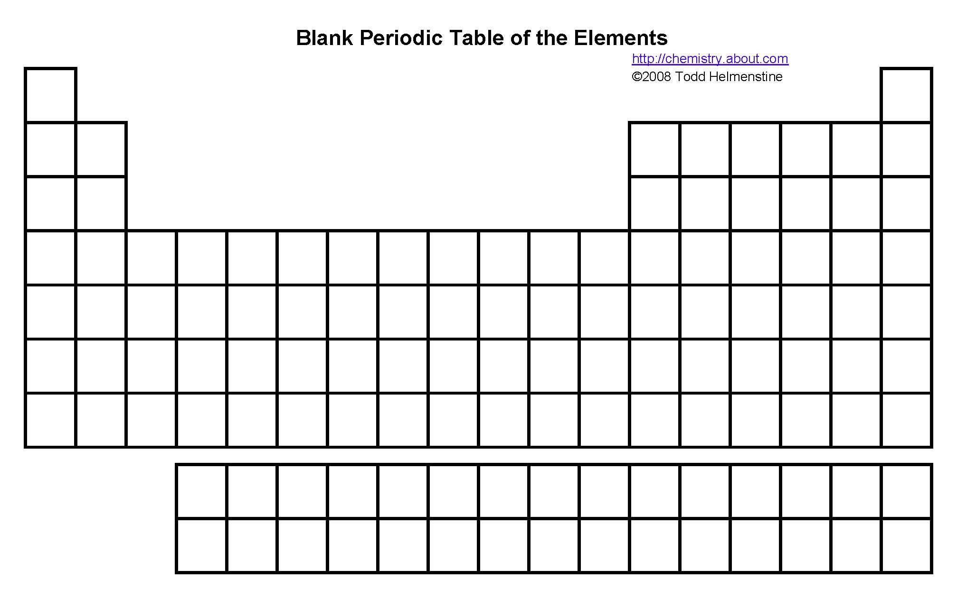
- Metallic Character
B. Blocks

