Name _______________________________ Date:_____________ Period:____

**Review Unit 8: Energy Changes & Reaction Rates**

1. What is heat? __________________________________________________________________
2. State the law of conservation of energy.

_________________________________________________________________________

1. If heat energy is absorbed by a chemical system, a greater / equal / lesser amount of energy will be released by the surroundings.
2. Describe the direction of heat flow when a hot rock is placed into cool water.

Heat flows from _____________________ to _______________________ making the

___________________ cooler and the ____________________ warmer.

1. In an endothermic reaction, heat is ____________________ by the system.
2. In an exothermic reaction, heat is ____________________ by the system.
3. Label each of the following processes as *endo*thermic or *exo*thermic:

______________ solid ice melting into liquid

______________ liquid water evaporating into gas

______________ water vapor condensing into liquid

______________ liquid water freezing into solid ice

______________ solid carbon dioxide (dry ice) subliming into carbon dioxide gas

1. If you are holding a beaker in which an exothermic reaction is occurring, the beaker would feel

warmer / cooler to the touch because the *system* is releasing energy to / absorbing energy from

the ______________________ which is your hand.

1. In a(n) _____________________ reaction, the reactants are at a lower energy than the products.
2. In a(n) _____________________ reaction, the products are at a lower energy than the reactants.
3. When chemical bonds are *formed*, energy is __________________;

energy is __________________ in order to *break* chemical bonds.

1. In an endothermic reaction, which has stronger bonds – reactants or products? _______________
2. In an exothermic reaction, which has stronger bonds – reactants or products? _______________
3. The potential energy diagram is for an **ENDOTHERMIC** / **EXOTHERMIC** reaction. *(circle one)*

Label the **reactants**, the **products**, **activation energy** (***Eact*),** and **change in energy** (**Δ*E***) .

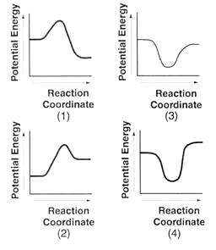

potential

energy

reaction progress

***Circle*** the correct statement.

In an exothermic reaction, heat is absorbed from / released to the surroundings,

and the surroundings cool down / warm up.

Touching the beaker with this reaction would feel cooler / warmer , and a thermometer would

show the temperature lowering / rising .

1. The potential energy diagram is for an **ENDOTHERMIC** / **EXOTHERMIC** reaction. *(circle one)*

Label the **reactants**, the **products**, **activation energy** (*Eact*), and **change in energy** (Δ*E*) .

potential

energy

reaction progress



***Circle*** the correct statement.

In an endothermic reaction, heat is absorbed from / released to the surroundings,

and the surroundings cool down / warm up.

Touching the beaker with this reaction would feel cooler / warmer , and a thermometer would

show the temperature lowering / rising .

1. Circle EACH of the following that could express a reaction rate in amount per time:

mol/L g/s s/mol mol/min g/mol

1. Reactant particles must __________________ in order for a reaction to occur.
2. To be effective, a collision requires the proper _____________________ of particles and it must occur with _____________________________________ to react.
3. Define activation energy: _________________________________________________________________________
4. Identify how **increasing** each of the following factors affects the a reaction rate:

1) concentration of reactants effect on rate: increases *or* decreases

2) temperature effect on rate: increases *or* decreases

3) surface area of reactants (smaller particles) effect on rate: increases *or* decreases

4) stirring effect on rate: increases *or* decreases

5) catalyst effect on rate: increases *or* decreases

1. Explain why increasing the concentration of reactants increases the reaction rate.

Higher concentrations cause more _____________________ between ___________________.

1. Explain why a reaction rate increases with an increase in temperature.

Higher temperatures cause more ____________________ of greater ____________________.

1. Reaction rates increase with smaller / larger particle sizes which provide less / more surface area of reactant available for collisions.
2. A catalyst is a substance that _________________ the reaction rate.

It works by _________________ the __________________________________.

Catalysts do not ___________________________ in the reaction and are left ________________.



**reaction progress**

1. Consider reactions **B** and **C** above.

The different heights of reactions B and C represent the _________________________ of the

reaction.

Reaction ___ is a catalyzed reaction, while Reaction ___ is an uncatalyzed reaction.

Reaction B has a lower / higher activation energy and occurs at a slower / faster rate.

**HONORS QUESTION**

[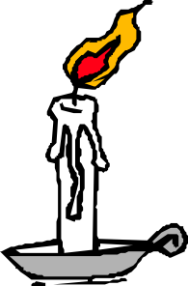](javascript:edit(10942))

[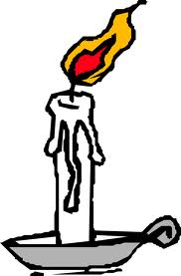](http://www.google.com/imgres?imgurl=http://www.clker.com/cliparts/7/7/8/5/119543321781687107liftarn_Burning_candle.svg.hi.png&imgrefurl=http://www.clker.com/clipart-10942.html&usg=__hO9-ipPBLkyQGuYSvoMeMWcriVo=&h=592&w=390&sz=26&hl=en&start=67&sig2=JesXSn5QPG4OooMYVa0rfQ&zoom=1&tbnid=mZEAfZf5m7-UqM:&tbnh=140&tbnw=92&ei=gbHMTJeoE8qr8AbqnoXEAQ&prev=/images?q%3Dcandle%2Bburning%2Bdrawing%26hl%3Den%26biw%3D1276%26bih%3D590%26gbv%3D2%26tbs%3Disch:1&itbs=1&iact=hc&vpx=717&vpy=78&dur=454&hovh=277&hovw=182&tx=98&ty=164&oei=bbHMTML3NIP48Aam6ZWTAQ&esq=4&page=4&ndsp=22&ved=1t:429,r:4,s:67)

1. Consider a candle on a table that burns continuously without going out.

Would you classify this system as OPEN, CLOSED, or ISOLATED? Explain.

__________________ because _______________________________________________

________________________________________________________________________ ________________________________________________________________________