Complete and study this packet and you should do well on the final exam!
Define/describe each of the following branches of forensic science:
Ballistics
Dactylography
Forensic Anthropology
Forensic Entomology
Forensic Pathology – Medical Examiner
Forensic Serology
Forensic Toxicology
Forensics or Criminalistics

Describe the forensic science contributions made by each of the following important scientists:
Carl Landsteiner
Edmund Locard
Alec Jeffreys

Define each of the following categories of evidence and give examples of each:
Direct or testimonial
Circumstantial (indirect)
Individual
Class
Trace

Record descriptions, definitions, and/or any important information about each of the following:
Securing the crime scene
Innocence Project
Packaging Evidence-
what kind of containers for different types of evidence
Chain of Custody
Locard’s Exchange Principle

Define and describe each of the following hair topics:
Follicle
Shaft
Cuticle
Cortex
Medulla
What protein makes up hair?
Primary vs. Secondary Transfer
DNA in hair
Pigments in hair / Colors

Define and describe each of the following fiber topics:
Importance of early collection of fiber evidence
First step of matching fiber to location

For each of the Natural Fibers list where they come from and any important facts about each:
 | Where fiber comes from: | Important facts:
Wool
Cashmere
Angora
Silk
Cotton
Coir
Linen
Sisal

For each of the Synthetic Fibers list any important facts about each:
Regenerated Fibers | Rayon
 | Acetate
Synthetic Polymer Fibers | Nylon
 | Acrylic
 | Polyester
 | Spandex

Define and describe each of the following fingerprint topics:
Patent Prints
Plastic Print
Latent Prints
Fingerprint Database
Ninhydrin
Cyanoacrylate
Vapor (super glue)
Silver
Nitrate
Iodine
Fuming
How to match fingerprints

Look back to the Fingerprint Notes and study the following pictures:
- Core B. Plain arch C. Plain whorl D. Ulnar loop E. Accidental whorl
F. Delta G. Tented arch H. Central Pocket whorl I. Radial loop J. Double loop whorl
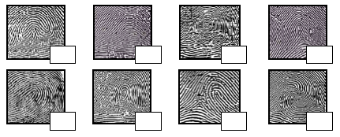
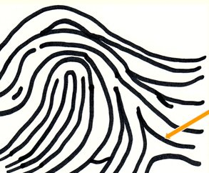
*All fingerprints are from a right hand
Blood and Blood Spatter Evidence -
 | Scientific Name | Function
RBC
WBC
Platelet

Define and describe each of the following blood topics:
DNA in blood
Blood Types and Blood Typing Test
Testing for blood at a crime scene
Shape of blood drops and blood spatter
Blood from mammal or other animal

Define and describe each of the following DNA Fingerprinting topics:
Gel Electrophoresis
PCR
DNA location in cells
Complementary Base Pairing
DNA Database
* Know how to read a DNA Fingerprint to determine paternity, parentage, & matches. (Pictures in notes)

