CHEMISTRY 2018-2019 FINAL EXAM TOPICS
Read over Carefully and Work through all Problems

OUTLINE OF TOPICS:
- Reading chemical equations (formulas, states of matter, etc)
- Stoichiometry
  - dimensional analysis (or the factor-label method)
  - Theoretical yield
- Lewis dot structures
  - Molecular polarity
- Electronegativity
  - Bond polarity
- States of matter
  - entropy
  - Phase changes
  - Phase change diagrams
- Kinetics
  - reaction rates and factors affecting reaction rate
  - open vs closed system
  - Endothermic reactions
  - Exothermic reactions
  - Activation energy
  - Catalyst
- Hydrogen bonding
- Solubility
  - Factors that affect solubility
- pH scale of acids and bases
- Concentration of solutions
  - Molarity
  - Dilution calculations
- Methods for separating mixtures
- Behavior of gases as V,T, P, or concentration changes
  - Gas law calculations
  - STP
  - Unit conversions

LEARNING STANDARDS:
HS-PS1-7. Use mathematical representations and provide experimental evidence to support the claim that atoms, and therefore mass, are conserved during a chemical reaction. Use the mole concept and proportional relationships to evaluate the quantities (masses or moles) of specific reactants needed in order to obtain a specific amount of product.
- Evaluations may involve mass-to-mass stoichiometry.
HS-PS1-4. Develop a model to illustrate the energy transferred during an exothermic or endothermic chemical reaction based on the bond energy difference between bonds broken (absorption of energy) and bonds formed (release of energy).
- Examples of models may include molecular-level drawings and diagrams of reactions or graphs showing the relative energies of reactants and products.
HS-PS1-5. Construct an explanation based on kinetic molecular theory for why varying conditions influence the rate of a chemical reaction or a dissolving process. Design and test ways to slow down or accelerate rates of processes (chemical reactions or dissolving) by altering various conditions.*
- Explanations should be based on three variables in collision theory: (a) quantity of collisions per unit time, (b) molecular orientation on collision, and (c) energy input needed to induce atomic rearrangements.
- Conditions that affect these three variables include temperature, pressure, and concentrations of reactants, agitation, particle size, surface area, and addition of a catalyst.
HS-PS3-4b. Provide evidence from informational text or available data to illustrate that the transfer of energy during a chemical reaction in a closed system involves changes in energy dispersal (enthalpy change) and heat content (entropy change) while assuming the overall energy in the system is conserved.
HS-PS1-3. Cite evidence to relate physical properties of substances at the bulk scale to spatial arrangements, movement, and strength of electrostatic forces among ions, small molecules, or regions of large molecules in the substances. Make arguments to account for how compositional and structural differences in molecules result in different types of intermolecular or intramolecular interactions.
- Types of intermolecular interactions include dipole-dipole (including hydrogen bonding), ion-dipole, and dispersion forces.
HS-PS2-8(MA). Use kinetic molecular theory to compare the strengths of electrostatic forces and the prevalence of interactions that occur between molecules in solids, liquids, and gases. Use the combined gas law to determine changes in pressure, volume, and temperature in gases.
HS-PS1-9(MA). Relate the strength of an aqueous acidic or basic solution to the extent of an acid or base reacting with water as measured by the hydronium ion concentration (pH) of the solution. Make arguments about the relative strengths of two acids or bases with similar structure and composition.
Clarification Statements:
- Reactions are limited to Arrhenius and Bronsted-Lowry acid-base reaction patterns with monoprotic acids.
- Comparisons of relative strengths of aqueous acid or base solutions made from similar acid or base substances is limited to arguments based on periodic properties of elements, the electronegativity model of electron distribution, empirical dipole moments, and molecular geometry. Acid or base strength comparisons are limited to homologous series and should include dilution and evaporation of water.
HS-PS1-11(MA). Design strategies to identify and separate the components of a mixture based on relevant chemical and physical properties.
HS-PS2-7(MA). Construct a model to explain how ions dissolve in polar solvents (particularly water). Analyze and compare solubility and conductivity data to determine the extent to which different ionic species dissolve.

- Calculations bases on quantitative relationships and balanced chemical equations are called stoichiometry.
Stoichiometric calculations are bases on the mole ratios between any two substances in the reaction.
What is the mole ratio between oxygen and water in the following reaction? 2H₂ + O₂ 2H₂O

- Use the mole map to help you solve conversions (don’t forget mole ratios!)
between moles, grams, numbers of molecules/atoms, and liters of gases at STP.
Given the reaction CH₄ + 2O₂ --> CO₂ + 2H₂O,
what amount of carbon dioxide is produced by the reaction of 1 mole of CH₄?
1 gram 1 liter 1 mole 22 grams

- Reactants are on the left side of the reaction arrow and products are on the right.
What are the names of the reactants in this neutralization reaction?
HCl(aq) + NaOH(aq) NaCl(aq) + H₂O(l)

- Lewis Electron dot structures represent covalently bonded molecules formed through the sharing
of valence electrons between atoms. It also shows the lone-pair(s) of electrons that may affect the shape and
polarity of the molecules.
Draw the Lewis structures for these common molecules H₂ H₂O NH₃ CH₄

- Exothermic reactions release energy (energy is a product of the reaction) while
Endothermic reactions absorb energy and the energy is a reactant in the reaction.
Given the reaction: CH₄ (g) + 2 O₂ (g) → 2 H₂O (g) + CO₂ (g) + heat
What is the overall result when CH₄ (g) burns according to this reaction?
Energy is absorbed Energy is released

- The gram formula mass (molar mass) of a substance is the sum of the atomic masses of all the atoms in it. H2SO4 = ______ g/mole

- 6.02 x 1023 is called Avogadro’s number and is the number of particles in 1 mole of a substance.
Equal volumes of gases contain an equal number of molecules.
Under similar conditions, which sample contains the same number of moles of particles as
1 liter of O₂ (g)? 1 L Ne(g) 0.5 L SO₂ (g) 2 L N₂ (g) 1 L H₂O(l)

- The kinetic molecular theory explains the behavior of matter as particles with energy and motion.

- Temperature is a measure of average kinetic. Which sample has the highest average kinetic energy?
H₂O (l) at 0ºC H₂O (s) at 0ºC CO₂ (g) at STP Mg (s) at 298K

- Reaction rate increases with an increase in temperature (and pressure for gases).

- Catalysts speed up reactions by lowering their activation energies.
They are not changed themselves and can be reused many times over.

- The particles in a solid are rigidly held together, closely packed in a lattice arrangement.
Which of the following has a regular geometric arrangement at 298 K and 1.0 atm?
Br₂ (l) CO₂ (g) Mg (s) H₂O (l)

- Solids have a definite shape and volume.

- Liquids have closely-spaced particles that easily slide past one another; they have no definite shape,
but have a definite volume.

- Gases have widely-spaced particles that are in random motion (collide with container to create pressure). Gases are easily compressed and have no definite shape or volume.

- Be able to read and interpret heating/cooling curves as pictured below.  During which interval on the graph are solid and  liquid in equilibrium? | 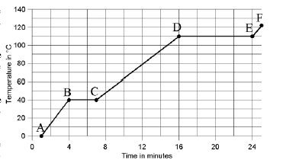
- Be able to read and interpret phase diagrams. At STP what phase of matter is the substance? At 1 atm, what is the melting point?
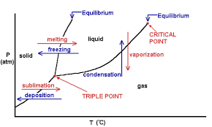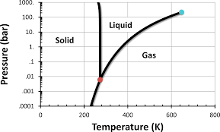

- Substances that sublime turn from a solid directly into a gas.
They have very weak attractive or intermolecular forces. (examples include CO2 & I2)
What type of intermolecular forces exist between molecules of CO₂ or I₂?

- “STP” means “Standard Temperature and Pressure.”

These conditions define STP P = _____atm = ______kPa T = _______K
- Degrees Kelvin = C + 273 Temperature is a measure of the kinetic energy of the particles in matter.
Room temperature = 25ºC = …….K Boiling point of helium = 4 K = ……….ºC

- Always use Kelvins for temperature when using the combined gas law. P₁V₁T₂ = P₂V₂T₁
Set up the equation to calculate the volume of 50. mL of methane gas collected at STP
when the pressure rises to 2.4 atm and the temperature drops to 240 K.

- As the pressure exerted on a gas increases, the volume decreases proportionally.
25 L of a gas is held at 1.2 atm pressure.
Find the new volume if pressure drops to 0.80 atm at constant temperature.

- As the pressure on a gas increases, temperature increases.
A sample of gas exerts a pressure of 220. kPa at 373 K. Find the pressure at 273 K at constant volume.

- As the temperature of a gas increases, volume increases. 15 mL of oxygen gas is collected at 0ºC. Find the volume at 50ºC at constant pressure.

- Real gas particles have volume and are attracted to one another. They don"t always behave like ideal gases.
Lighter gases (with weaker attractive forces) are often most ideal.
Which of the following is the most ideal gas?
He Ne Ar Kr

- Real gases behave more like ideal gases at low pressures and high temperatures.

- According to Avogadro’s law at constant temperature and pressure, the volume of a gas is directly
proportional to the number of moles. This is true for any gas.
At STP 22.4 L of any gas = 1 mole, what is this equality called?

- The Ideal Gas Law relates the pressure (atm), volume (L), temperature (K), and amount of gas particles
(moles) of a gas. The formula is PV = nRT where R is 0.0821 L•atm/mol•K
What is the volume occupied by 36.0g of water vapor at 125˚C and 0.999atm?

- The last digit of an element’s group number is equal to its number of valence electrons.
Which contains the greatest number of valence electrons?
Ca Ge Se Kr

- Draw one dot for each valence electron when drawing an element’s or ion’s Lewis electron dot diagram.
Which dot model would contain the fewest dots as valence electrons?
Ca Ge Se Kr

- Nonpolar covalent bonds form when two atoms of the same element bond together.

- Polar covalent bonds form when the electronegativity difference between two bonding atoms is between
0.4 and 1.7. Which of the following combinations would form a polar covalent bond?
H and H Na and N H and N Na and Br

- Ionic bonds form when the electronegativity difference between two bonding atoms is greater than 1.7.
Which of the following combinations would form an ionic bond?
H and H Na and N H and N Na and Br

- Polar molecules have stronger forces of attraction. They lack structural symmetry.
Which of the following is a polar molecule?
CO₂ H₂O C₄H₁₀ N₂

- Hydrogen bonds are attractive forces that form when hydrogen bonds to the elements N, O, or F and
gives the compound unexpectedly high melting and boiling points.
The strongest forces of attraction occur between molecules of
HCl HBr HF HI

- Solutions are the best examples of homogeneous mixtures. They have two sets of properties.

- Heterogeneous mixtures have discernible components and are not uniform throughout.
Air is classified chemically as a(n)
Substance compound element solution
- A solute is the substance being dissolved; the solvent is the substance that dissolves the solute.
NaCl (s) is added to water.
The solute is ….. the solvent is …… the solution is ……..

- Remember: substances tend to be soluble in solvents with similar molecular properties.
“Like dissolves like”
Pentane does not dissolve in water because pentane is ………. and water is ………..

- As temperature increases, solubility increases for most solids.
For which substance does increasing temperature have the least effect on solubility?
Sodium chloride calcium carbonate oxygen sodium bicarbonate

- At low temperatures and high pressures solubility increases for most gases.
Carbon dioxide gas is least soluble in water at conditions of …. temperature and .… pressure.

- Molarity is a way to measure the concentration of a solution.
Molarity is equal to the number of moles of solute divided by the number of liters of solution.
What is the molarity of an NaCl solution if 2.0 mol NaCl is present in 0.50 L solution?

- Molality = (moles of solute/ kg of sovent)
A solution of glucose is prepared by added 10. g glucose (C₆H₁₂O₆) to 40. g water.
What is its molality?

- Dilutions M₁V₁ = M₂V₂ is the way to determine how to make a less concentrated solution.
A student needs 250 mL of a 1.0 M HCl solution, how many mL of 6.0M HCl do they need to make this
solution?

- Increasing the concentration of reactants will increase reaction rate.
Which sample of HCl (aq) will react most rapidly with magnesium metal?
0.50 M HCl 1.0 M HCl 3.0 M HCl 6.0 M HCl

- Acids and bases are both good electrolytes. Their solutions conduct electricity well.
Which of the following is a nonelectrolyte?
LiOH HBr HC₂H₃O₂ C₂H₅OH

- Weak acids taste sour and react with metals.
- Weak bases taste bitter and feel slippery.

- Acids have a pH < 7. Bases have a pH > 7.

- Brønsted model of acids and bases states:
“Acids donate protons.” “Bases accept protons.”
Identify one Bronsted acid and one Bronsted base in the reaction below:
H₂O + NH₃ NH₄ ⁺ + OH⁻

Unit 7 Review: Stoichiometry
Final Exam Review
Part 2
1. What quantity is conserved in the reaction shown below? (circle all that apply)
2 HCl + Ca(OH)₂ → 2 H₂O + CaCl₂
atoms molecules moles mass (grams)

2. The law of conservation of mass states that in a chemical reaction ...
_________________________________________________________________

3. The quantities that must always be conserved in ALL chemical reactions are
__________ and _________.

4. It takes 4 eggs and 1 cup of milk to make 2 omelets. How many eggs would it take to make 6 omelets?

3 NH₄OH + Al(NO₃)₃ → 3 NH₄NO₃ + Al(OH)₃
5. In the reaction above, what is the mole ratio of Al(NO₃)₃ to NH₄OH ? ___ : ___

In stoichiometric problems, what is the mole ratio used to accomplish?
__________________________________________________________________________

Ca(OH)₂ + FeCl₂ CaCl₂ + Fe(OH)₂
150 g 90 g 128 g ? g
6. According to the reaction above, how many grams of Fe(OH)₂ should be formed? ______ g

7. Write the formula for percent yield:
% yield =

What is the amount of substance recovered from the reaction in the lab experiment called? ____________________

What is the theoretical yield? _______

SHOW ALL WORK --- BOX your ANSWER

8. 4 Na + O₂ 2 Na₂O
a) How many moles of sodium will react completely with 3.82 moles of oxygen (O₂)?

9. C₂H₄ + 3 O₂ 2 CO₂ + 2 H₂O
a) How many grams of C₂H₄ (28.06 g/mol) are needed to produce 3.70 grams of water?

11. Be + 2 HCl BeCl₂ + H₂
Enough Be and HCl were added to produce 10.7 grams of beryllium chloride (BeCl₂), but only 4.50 g BeCl₂ was actually recovered. What is the percent yield?

12. 2 LiOH + FeCl₂ 2 LiCl + Fe(OH)₂
a) You began this reaction with 20.0 grams of lithium hydroxide (LiOH) (23.95 g/mol). What is the theoretical yield of lithium chloride (LiCl) (42.39 g/mol) ?

b) You actually produced 6.00 grams of LiCl. What is the percent yield?

Review Unit 8: Energy Changes and Reaction Rates

- Heat – __________________________________________________________________________

- If heat energy is absorbed by a chemical system, a greater / equal / lesser amount of energy will be released by the surroundings.
- In an endothermic reaction, heat is ________________ by the system.

- In an exothermic reaction, heat is _________________ by the system.

- ____________ solid ice melting into liquid
____________ liquid water evaporating into gas
____________ water vapor condensing into liquid
____________ liquid water freezing into solid ice
____________ solid carbon dioxide (dry ice) subliming into carbon dioxide gas
- If you are holding a beaker in which an exothermic reaction is occurring, the beaker would feel _____________ to the touch because the system is _____________________ the ________________ which is your hand.

- In an ___________________ reaction, the reactants are at lower energy than the products.
- In an ________________________reaction, the products are at a lower energy than the reactants.

- When chemical bonds are formed, energy is __________________;
energy is _______________________ in order to break chemical bonds.
- In an endothermic reaction, which has stronger bonds – reactants or products
- In an exothermic reaction, which has stronger bonds – reactants or products

- The potential energy diagram shown is for an ENDOTHERMIC / EXOTHERMIC reaction. (circle one)

potential
energy

reaction progress
E_{act}
R

ΔE
P

Circle the correct statement.
In an exothermic reaction, heat is ___________________________ the surroundings,
and the surroundings ___________________
Touching the beaker with this reaction would feel ________________ and a thermometer would show the temperature ____________.

- The potential energy diagram is for an ENDOTHERMIC / EXOTHERMIC reaction. (circle one)

potential
energy

reaction progress
E_{act}
P

ΔE
R

Finish the correct statement.
In an endothermic reaction, heat is ____________________________ the surroundings,
and the surroundings _________________________.
Touching the beaker with this reaction would feel ______________, and a thermometer would
show the temperature ______________________.
Unit 8 Reaction Rates

1. In a typical reaction, as reaction progresses, the amount of _____________ decreases, and the amount of _______________ increases.

2. According to collision theory, a reaction can only occur if the particles collide with the proper _________________ and with enough __________________ to react.

3. TRUE or FALSE (if false, change the statement to make it true)
Particles lacking the necessary kinetic energy to react bounce apart unchanged when they collide.

4. The minimum energy that particles must collide with in order to react is called _____.
A. kinetic energy C. potential energy
B. activation energy D. collision energy

5. An activated complex is an unstable arrangement of atoms that forms momentarily at the peak of the ______________________ ______________ barrier. It either re-forms into the _________________ or forms into ___________________.

6. An increase in the temperature of a reaction will _______________ the rate of the reaction because more particles will ________________________________________.

7. What happens to the rate of a reaction when some of the reactants are removed? (lower concentration) The rate ___________________ because _______________________________________________.

8. Increasing the surface area of the reactants will ________________ the rate of reaction. Many smaller particles have ________ surface area than few large particles.

9. A substance that increases the rate of reaction without being used up itself is called a ____________.

10. Label the Activation Energy (E_{act}) and the change in energy (ΔE)on the energy profiles below. Which is exothermic and which is endothermic?
Enthalpy
Reactants
Products
Reaction proceeds
Enthalpy
Reactants
Products
Reaction proceeds
Enthalpy
Reactants
Products
Reaction proceeds

Unit 9 Molecules and Polarity
The Polarity of a molecule ultimately is determined by the shape of the molecule and whether or not it is symmetrical.

Review Bonding

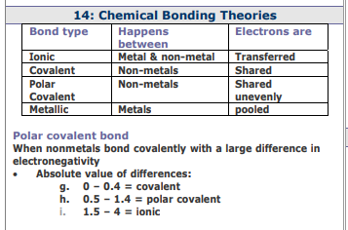
- There are strong attractions between polar water molecules which cause water to have all of the following properties EXCEPT ____.
A. surface tension
B. liquid of greater density than
solid (ice)
C. attraction to nonpolar
molecules
D. higher boiling point

- Hydrogen sulfide (H₂S) boils at –60ºC. Even though water is a smaller molecule that should become a gas easier than H₂S, water doesn’t boil until it reaches 100ºC.

Why do water molecules require a much higher temperature to become a gas?

Review Lewis Structures
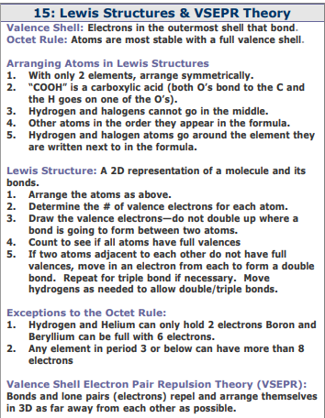

Unit 10 States of Matter Practice
For #23-26, refer to the heating curve below for water as heat is added at a constant rate.

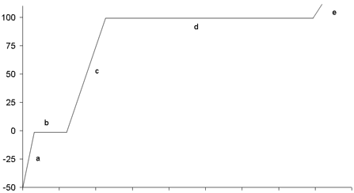
Temperature (ºC)
Heat added

23. Circle which phase(s) of water exist(s) in each section of the heating curve.
section A. solid liquid gas
section B. solid liquid gas
section C. solid liquid gas
section D. solid liquid gas
section E. solid liquid gas

24. Circle which type of energy is increasing in the sample during each section as heat is being added.
section A. kinetic potential
section B. kinetic potential
section C. kinetic potential
section D. kinetic potential
section E. kinetic potential

25. If heat were removed instead of added, the process occurring in section D would be _____.

A. vaporization
B. freezing
C. condensation
D. NONE of the above

26. Section B is shorter than section D because water has a lower heat of __________________
than heat of _____________________ so it takes more energy to ___________ a sample of water than it
does to ____________ the same sample of water.
27. A cup of water contains 55 g of water at a temperature of 21.4ºC. How much heat must be
removed from the water to lower its temperature to 2.5ºC? (the specific heat of water is 4.18 J/gºC)

For #28-33, refer to the phase diagram below for water.
5
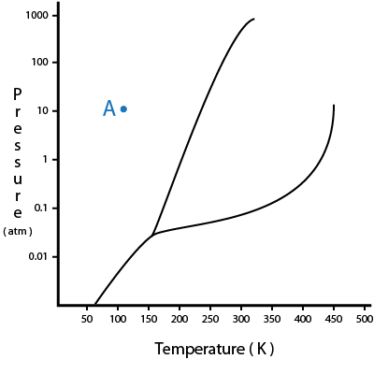
B
A
3
2
4
1
Label each section on the diagram
(A, B, C)
with the correct phase
(s, l, g)

C

28. The phase change from A to C is called _______________ and from C to B is ______________.

29. The boiling point of the substance is shown at Point ___ which is the point at which
___________ and ___________ phases coexist in equilibrium.

30. Point 4 represents the ___________ point, which is the point at which…
________________________________________________________________.

31. The critical point is shown at Point ___ which represents the temperature above which a
____________ could not exist and the pressure above which a _____________ could not exist.

32. A sample of the substance is held constant at a temperature of 300 K while the
pressure is decreased from 10 atm to 0.01 atm. The phase change that occurs is ______________.

33. A sample of the substance is held constant at a pressure of 1 atm while the temperature
is increased from 150 K atm to 250 K. The phase change that occurs is ______________.
Unit 11: Gas Laws
- List 3 variables and how you would change them to increase the pressure of a gas.
a)
(collisions with walls of container)
b)
c)

- What happens to gas pressure if its volume is decreased? increase or decrease

- What happens to the volume of a gas if the pressure is increased? increase or decrease

- What happens to the volume of a gas if the temperature is increased? increase or decrease

- What happens to the temperature of a gas if the volume is increased? increase or decrease

For #6-8, you may refer to the following relationships:
R = 0.08206 L∙atm
mol∙K
PV = nRT
1 atm = 760 mmHg = 101.3 kPa

K = ºC + 273
Ideal gas at STP = 22.4 L∙mol^{–1}
STP = 273 K & 1.0 atm

- 2.00 L of a gas at 2.50 atm is compressed to a volume of 0.50 L.
What is the pressure if the temperature is constant?

- 5.00 L of a gas at 273°C and 760 mmHg is stored in a flexible container.
What is the volume at STP?

.
- A 3.50 mol sample of a gas at 305 K and a pressure of 800 mmHg. What is the volume of the gas?

Unit 12 Solutions

Part A: Solutions & Solubility

- A solution consists of a _____________________ dissolved in a _________________. It is also known as a _________________________ mixture. It has a _____________________ composition.
- Circle the solute and underline the solvent.
- 85% isopropyl alcohol in 15% water
- 60 mL of oil in 4 L of gasoline
- Sugar water
- Solubility is a measure of the ________________ amount of ______________ that can dissolve in a given amount of ____________ at a specific temperature.
- The 3 factors that affect how fast a solid solute dissolves (rate of dissolving) are __________________, _________________________, and ________________________.
- Gases are more soluble at high __________________ and low ___________________.
- What phrase describes the types of substances that will dissolve in each other: _______ dissolves _______.
Accordingly, polar solvents (like water) can dissolve _________ solutes (alcohols, sugars, ionic
compounds, etc.), and nonpolar solutes (fats, oils, hydrocarbons, etc.) will dissolve in __________ solvents.
- a) Molarity is the ratio of ________________________________ per liter of solution.
b) A 12.0 molar solution of H₂SO₄ consists of ______ moles of __________ in _____ liter(s) of ____________.
- There is a large amount of solute dissolved in a concentrated / dilute solution.
- How do you dilute a solution? __________________________________________________________.
- The molarity of a solution increases / decreases / stays the same when it is diluted, and the number of moles increases / decreases / stays the same.

Use the solubility curve below to answer questions 11 - 13.
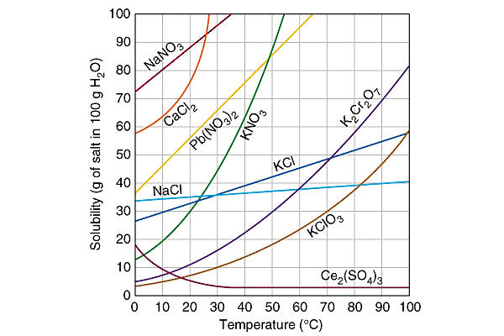
- If ALL of the solute could be dissolved in 100 g of water at the given temperature, would the resulting solution be unsaturated, saturated, or supersaturated?

40 g KCl at 30°C ___________________ c) 75 g NaNO₃ at 10°C __________________

10 g KClO₃ at 30°C ___________________ d) 35 g NaCl at 60°C __________________
- Which substance has the lowest solubility at 10°C? _____________

- How many grams of K₂Cr₂O₇ can dissolve in 100 g of water at 50°C? __________

Part B: Molarity & Dilutions Calculations

mol
L
M =
M₁V₁ = M₂V₂

- What is the molarity of a solution containing 85 g NaOH in 775 mL of solution?

- How many moles are in 3.20 L of a 2.50 M solution of potassium iodide?

- How many mL of a 0.150 M NaBr solution are needed to make 100 mL of 0.0500 M NaBr?

UNIT 13: Acids and Bases

1. List 3 properties of acids: List 3 properties of bases:
taste: _________ taste: ___________
litmus color:______ litmus color: ______
________________________________ __________________________

- For the following reaction label the Bronsted-Lowry Acid, Base, Conjugate Acid and Conjugate Base:
H₂O + CO₃²⁻ OH⁻ + HCO₃⁻

For #3 - 4, you may use the following relationships:
pH = –log[H⁺]
K_{w} = [H⁺][OH–] = 1 x 10^{–14}
pH + pOH = 14

- Determine the pH and Label each of the following as acidic (A), basic (B), or neutral (N).
pH acidic (A), basic (B), neutral (N)
a) hydrogen ion concentration of 1 x10^{–3} M
b) [H⁺] = 1 x10^{–9} M
c) [OH–] = 1 x10^{–8} M

b) [H₃O⁺] = 1.0 x10^{–7} M
c) 0.150 M hydronium ion

- Calculate the pOH for a solution of pH = 1.80.

For #5 - 7, you may use the following relationships:
pH + pOH = 14
pH = –log[H⁺]
K_{w} = [H⁺][OH–] = 1 x 10^{–14}

- Calculate the pH for a solution of 1 x 10^{–9} [OH⁻].

- Calculate the [H⁺] for a solution of 9.16 x 10^{–8} M [OH⁻].

For #7, you may use the following relationship:
M_{A}V_{A} = M_{B}V_{B}

- 10.0 mL of NaOH of unknown concentration is titrated by adding exactly 15.8 mL of 0.150 M
HCl to completely neutralize the base.

- Write the balanced equation for the neutralization of this reaction.

NaOH + HCl

- What was the concentration of NaOH?

