Name: _______________________________________________ Date: _______________________________ Period: ______________
Directions: Use a pencil and a ruler to NEATLY draw, label, and color the figures. Answer the questions about each picture or define the specified words.
Cuticle:

Cortex:

Medulla
Figure 3-3: Cross section of hair shaft. (In the textbook, page 54)

Description:

How can hair be used as class evidence?
How can hair be used as individual evidence?
Figure 3-2: Cross section of hair follicle. (In the textbook, page 53)

Figure 3-5: Medulla Pigmentation Patterns. (In the textbook, page 54) Figure 3-12: Cuticle patterns can be used to identify human hair or other animal hair.(Book p. 58)
Medulla Pattern | Description | Diagram
Continuous
Interrupted (intermittent)
Fragmented or Segmented
Solid
None
Cuticle Pattern | Diagram
Imbricate

Species:
Coronal

Species:
Spinous

Species:

Figure 4 from lab handout: Medulla Structures
Describe the three stages of hair growth:
Anagen:

Catagen:

Telogen:
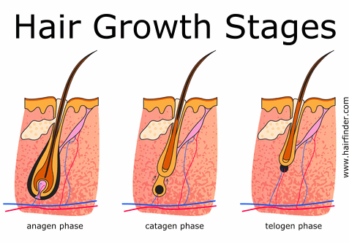

Medulla Structure | Diagram/Drawing
Uniserial
Multiserial
Vacuolated
Lattice
Amorphous
Bonus: Looking at figure 3-10 on page 57 in your textbook, how can the distribution of pigment granules in a sample of hair help you identify someone’s ancestry?

