Review for Mid-Year Exam
Learning Standards:
HS-PS1-1. Use the periodic table as a model to predict the relative properties of main group elements, including ionization energy and relative sizes of atoms and ions, based on the patterns of electrons in the outermost energy level of each element. Use the patterns of valence electron configurations, core charge, and Coulomb’s law to explain and predict general trends in ionization energies, relative sizes of atoms and ions, and reactivity of pure elements.
HS-PS1-2. Use the periodic table model to predict and design simple reactions that result in two main classes of binary compounds, ionic and molecular. Develop an explanation based on given observational data and the electronegativity model about the relative strengths of ionic or covalent bonds.
- Simple reactions include synthesis (combination), decomposition, single displacement, double displacement, and combustion.
- Predictions of reactants and products can be represented using Lewis dot structures, or chemical formulas.
- Observational data include that binary ionic substances (i.e., substances that have ionic bonds), when pure, are crystalline salts at room temperature (common examples include NaCl, KI, Fe₂O₃); and substances that are liquids and gases at room temperature are usually made of molecules that have covalent bonds (common examples include CO₂, N₂, CH₄, H₂O, C₈H₁₈)
HS-PS1-7. Use mathematical representations and provide experimental evidence to support the claim that atoms, and therefore mass, are conserved during a chemical reaction. Use the mole concept and proportional relationships to evaluate the quantities (masses or moles) of specific reactants needed in order to obtain a specific amount of product.
- Mathematical representations include balanced chemical equations that represent the laws of conservation of mass and calculations of percent yield.

OUTLINE OF TOPICS WE HAVE COVERED

- Basic atomic structure
- Bohr Model of atoms
- Isotopes
- Valence electrons
- Drawing Lewis dot structures
- Organization of the Periodic Table
- Classification of elements (metals, nonmetals, metalloids)
- Families of elements
- Ionization Energy
- Relative atomic and ionic size
- Electronegativity
- Reactivity
- Ion formation
- Lewis structures
- Formation of ionic compounds
- Ionic bonding properties and formulas
- Naming and writing formulas of ionic compounds
- Properties of Ionic Compounds
- Naming and writing formulas of covalent compounds
- Lewis structures
- Properties of Covalent Compounds
- Diatomic elements
- Chemical change vs physical change
- Types of Reactions
- Writing and Balancing Equations
- Molar Mass and Mole Conversions (moles, mass, volume, # particles)
- % Composition
- Empirical Formulas
- Molecular Formulas

The periodic table contains information for every element.
Define the terms atomic number, atomic weight, and mass number. Identify the atomic number, atomic weight, and mass number for carbon based on the information on your periodic table.

Atomic structure for any element can be determined from the information on the periodic table.
Describe the three subatomic particles, their charges, sizes, and locations in an atom.
Determine the number of protons, neutrons, and electrons for a Boron atom.

Bohr Models represent the structure of the atom with protons and neutrons in the nucleus and electrons on “rings” outside of the nucleus. Remember the first ring holds 2, the second ring holds 8, and the third ring holds 18.
Draw the bohr models for Na and Cl and Ar

Isotopes are atoms of the same element because they have the same number of protons but a different number of neutrons.
Determine the number of protons, neutrons and electrons in Hydrogen-1, hydrogen-2, and hydrogen-3

The last digit of an element’s group number is equal to its number of valence electrons.
Which contains the greatest number of valence electrons?
Ca Ge Se Kr

Draw one dot for each valence electron when drawing an element’s or ion’s Lewis electron dot diagram.
Which dot model would contain the fewest dots as valence electrons?
Ca Ge Se Kr

There are various trends that can be found on the periodic table. Define atomic radius, electronegativity, ionization energy, and electron affinity. Identify their trends using arrows and the words “increasing” or “decreasing” on the periodic table below.

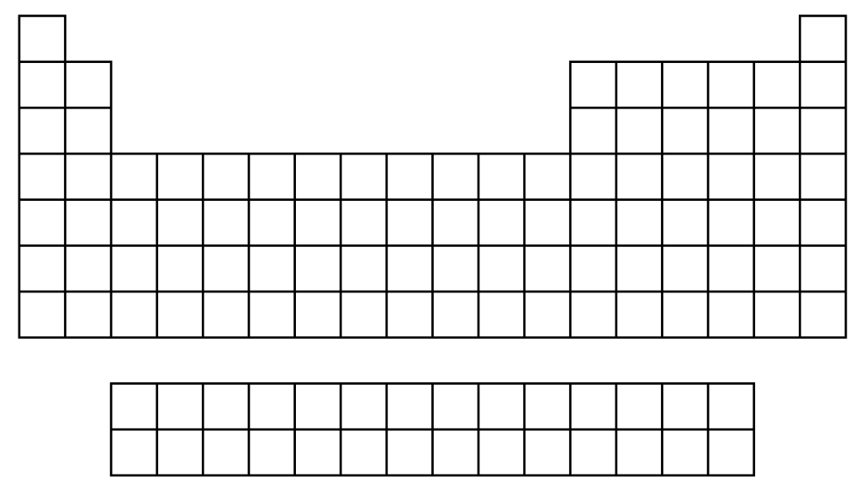

The three classes of elements on the periodic table are metals, nonmetals, and metalloids. Describe their general characteristics. Color all of the metals green, the metalloids red, and the nonmetals blue on the table above.
Atoms are most stable when they have 8 valence electrons (an octet) and tend to form ions to obtain such a
configuration of electrons.
Predict the charge of the ions formed by these elements
Li F Na Cl

Chemical formulas are written so that the charges of cations and anions neutralize (cancel) one another.
calcium phosphate: Ca2+ PO43- = ………… (criss-cross)

When naming binary ionic compounds, write the name of the positive ion (cation) first,
followed by the name of the negative ion (anion) with the name ending in “-ide.”
CaCl₂ …………….. MgS ……………..

When naming compounds containing polyatomic ions, keep the name of the
polyatomic ion the same as it is written on your reference sheet.
NH4Cl ………. copper (I) nitrate ……….

Roman numerals are used to show the positive oxidation number of the cation if it has more than
one positive oxidation number
FeO: ……………………. Nickel (III) sulfate: ……………..

Ionic bonds form when one atom transfers an electron to another atom when
forming a bond with it.
Which substance exhibits ionic bonding rather than covalent bonding?

CO₂ N₂O₄ SiO₂ CaBr₂ C₆H₁₂O₆

Ionic bonds form when the electronegativity difference between two bonding atoms is great enough to cause the transfer of electrons.
Which of the following combinations would form an ionic bond?
H and H Na and N H and N Na and Br

Covalent bonds form when two atoms share a pair of electrons.
How many covalent bonds are found in a nitrogen (N₂) molecule?

Substances containing mostly covalent bonds are called molecular substances.
They are attracted to each other by sharing electrons
Which of the following is a molecular substance?
Lithium chloride carbon monoxide sodium nitrate aluminum oxide

Lewis Electron dot structures represent covalently bonded molecules formed through the sharing
of valence electrons between atoms.
Draw the Lewis structures for these common molecules H₂ H₂O NH₃ CH₄

When naming a binary molecular compound, the first element is named using the name of the element.
The second element always end in “–ide.” Indicate the number of atoms using the prefix…
1 mono 2 di 3 tri 4 tetra 5 penta 6 hexa 7 hepta 8 octa 9 nona 10 deca
If the first element has only one atom, don’t use the mono.
What is the name of the following molecular compounds?
CO₂ ___________________________ N₂O___________________________

Complete and memorize this table
Substance Type | Properties
Ionic
Covalent (Molecular)

Physical changes do not form new substances.
They merely change the appearance of the original material. (The melting of ice) H₂O (s) H₂O (l)

Chemical changes result in the formation of new substances or the product(s) of a chemical reaction.
Which process is an example of a chemical change?
the melting of ice the electrolysis of water the boiling of water

Reactants are on the left side of the reaction arrow and products are on the right.
What are the names of the reactants in this reaction?
HCl(aq) + NaOH(aq) NaCl(aq) + H₂O(l)

Coefficients are written in front of the formulas of reactants and products to balance chemical
equations. They give the ratios of reactants and products in a balanced chemical equation.
……..Na + …….Cl₂ ………NaCl

Only coefficients can be changed when balancing chemical equations!
Given the unbalanced equation: Al + O₂ = Al₂O₃
When this equation is balanced using the smallest whole numbers, what is the coefficient of Al?

Synthesis reactions occur when two or more reactants combine to form a single product.
balance the following synthesis reaction
Na (s) + Cl2(g) NaCl (s)

Decomposition reactions occur when a single reactant forms two or more products
balance the following decomposition reaction
CaCO3(s) CaO(s) + CO₂ (g)

Single replacement reactions occur when one element replaces another element in a compound.
Which equation below represents a reaction classified as a "single replacement" reaction?
2 H₂ + O₂ --> 2 H₂O
Pb(NO₃) ₂ + K₂CrO₄ --> 2 KNO₃ + PbCrO₄
HCl + NaOH --> H2O + NaCl
Cu + Zn(NO₃) ₂ --> Zn + Cu(NO₃) ₂
CaCO₃ --> CO₂ + CaO

Double replacement (displacement) reactions occur when two compounds react to form two new compounds.
Potassium sulfide (K₂S) is mixed with lead acetate(Pb(C₂H₃O₂)₂). Which of the following products is
expected? PbSO₄ K₂S K₃PO₄ PbS

Combustion reactions occur when a hydrocarbon burns in the presence of oxygen gas to produce carbon
dioxide gas and water vapor. Write the combustion reaction for the combustion of methane gas (CH₄)
CH_{4 (g)} + _____ ______ + _______ *balance

The masses (and energy) of the reactants in a chemical equation is always equal to the masses (and energy) of the products. “Law of Conservation of Mass (and Energy).”
For the reaction: CaCO₃ --> CO₂ + CaO
If 20.0g of CaCO₃ decomposes to for 19.5 g of CaO, how many grams of CO₂ gas is formed? _____

The gram formula mass (molar mass) of a substance is the sum of the atomic masses of all the atoms in it. H2SO4 = ______ g/mole
2 x H = 2 x ………g = ………g
1 x S = 1 x ………g = ………g
4 x O = 4 x………g = ………g

Use the mole map to help you solve conversions
What is the mass in grams of 3.6x10²¹ molecules of sugar? C₁₂H₂₂O₁₁
What is the mass in grams of NaCl that was dissolved in 3.2 L to create a 1.6M solution?

An empirical formula is the simplest mole ratio among the elements in a compound.
Find the empirical formula of a compound composed of 75% carbon and 25% hydrogen.

A molecular formula is the true formula of a molecular compound.
Find the molecular formula of the compound from problem 32, if its molecular mass is 48.15 g/mol

Know how to calculate the percentage composition of a compound.
Find the percent by mass of oxygen in CaCO₃.

Know how to convert an empirical formula into a molecular formula.
A compound has the empirical formula NO₂. Find its molecular formula if the molar mass = 92g.
N₂O NO₂ N₂O₄ N₂O

Molarity is a way to measure the concentration of a solution.
Molarity is equal to the number of moles of solute divided by the number of liters of solution.
What is the molarity of an NaCl solution if 2.0 mol NaCl is present in 0.50 L solution?

Covalently bonded substances form molecules. Molecular compounds are made up of nonmetals only.
Which of the following are molecular compounds? H₂O CH₄ NaCl CuSO₄ CO₂

The formula of a molecular compound represents one molecule of the substance, also one mole of
molecules and the number of atoms for each nonmetal element making up the molecule.
The formula for methane gas, CH₄, tells us the make-up of one molecule of methane is 1 carbon atom and 4 hydrogen atoms covalently bonded together. We can also figure out the molar mass or the mass in one mole of methane. What is the molar mass of CH₄? 47 g/mol 24 g/mol 16 g/mol 10 g/mol

What does it mean to say an element is diatomic? What are the 7 diatomic elements?

Write the balanced chemical equation for the following reaction. Be sure to include the symbols for the correct state of matter.
Crystal sugar is heated in the presence of oxygen gas to produce carbon dioxide gas and water vapor.
Aqueous magnesium sulfate reactions with aqueous barium chloride to produce solid barium sulfate and aqueous magnesium chloride.

