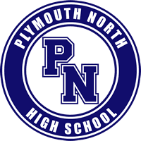
PLYMOUTH NORTH HIGH SCHOOL
Putting “Thanks” in Thanksgiving

As part of our “Go North” November, we are encouraging our students to give thanks to loved ones that have helped support them in their families and community. Our hope is that our students have an avenue and opportunity to express how thankful they are for your support, and to make your Thanksgiving that much more bright!

TO (Loved One/Family Member): ________________________________
FROM (PNHS Student): ________________________________________
MESSAGE:

*Please address your envelope and place the letter in the envelope, or if you don’t have an envelope… put the address here:
________________________________________________________________
________________________________________________________________
________________________________________________________________
________________________________________________________________
Happy Thanksgiving from Plymouth North High School!

