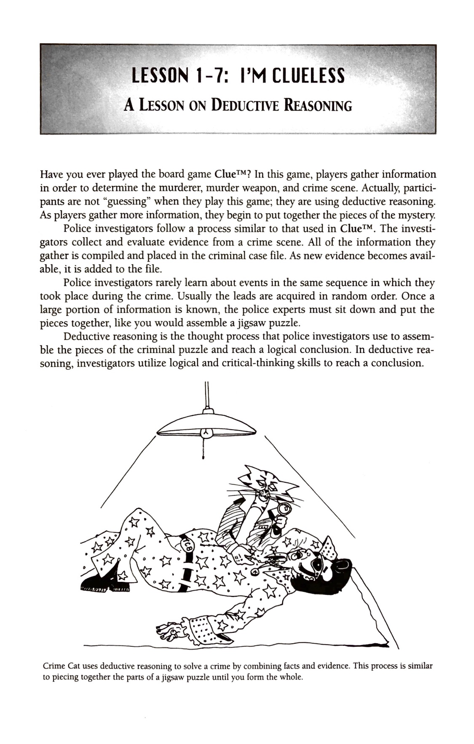

The Deadly Picnic
A Lab on Deductive Reasoning

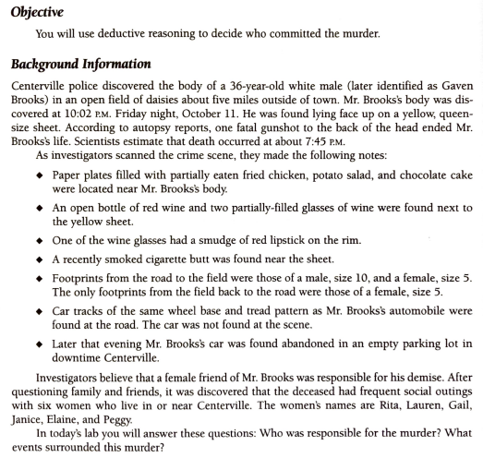

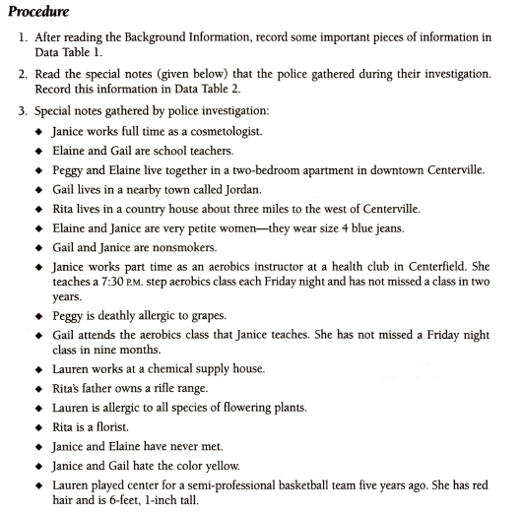

In your Assignment in Google Classroom, I will include a digital copy of the data tables that you can complete online or you may set up the tables on paper if you are unable to complete the tables online. In the Assignment, you will find your Post-lab questions that you must complete as well.

